

**USER INTERFACE TEST CASES**

UA1-SO

The UI testing for our project is done featuring the core features of the *askit* website. These features are listed below:

* **Login/Sign Up** Registration procedure
* Question functionalities
  + **Ask** and/or **Answer** some questions
  + **Upvote** or **Downvote** a question
* Profile Settings
  + Add a **profile picture**
  + **Modify** an account’s password
  + Change a **description** of an account

1. **SIGN UP REGISTRATION PROCEDURE**

To successfully create an account, the user needs to follow these requirements:

1. Enter a username of at least 4 characters.
2. Enter a password between 8 and 20 characters.
3. Choose both security questions and give answers to both.
4. Select a profession
5. Select a gender
   1. Creating a new account with wrong username Image result for check



* 1. Creating a new account with wrong password Image result for check



* 1. Creating a new account without selecting question Image result for check

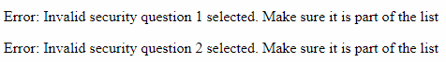

* 1. Creating a new account without answering question Image result for check



* 1. Creating a new account without selecting profession Image result for check



* 1. Creating a new account without selecting a gender Image result for check



* 1. Creating a new account following the requirements Image result for check

Redirected to login!

1. **QUESTION FUNCTIONALITIES**

To successfully create a question, a user needs to be connected, and then clicking on “New Question”.

* 1. Not Logged in Image result for check

**The user does not have an option to add a question.**

* 1. Logged in Image result for check



* 1. Text area appears, and question can be asked Image result for check

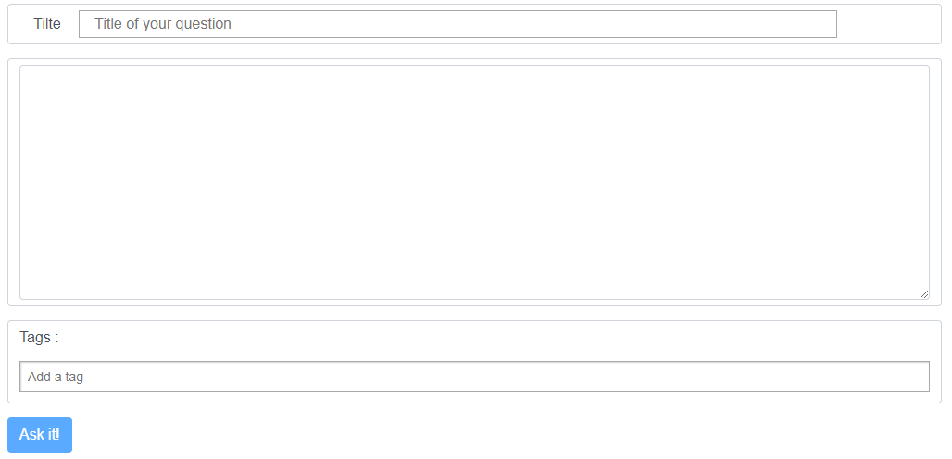

* 1. *Ask it!* button posts the question online Image result for check

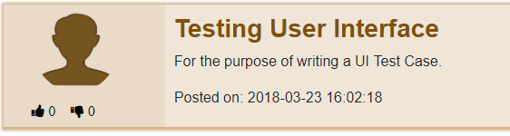

1. **PROFILE FUNCTIONALITIES**
   1. Changing profile Picture Image result for check

**The user does not have an option to change picture.**

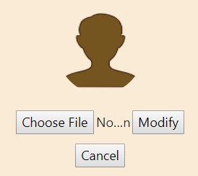

* 1. Modify Password option modifies the actual password Image result for check

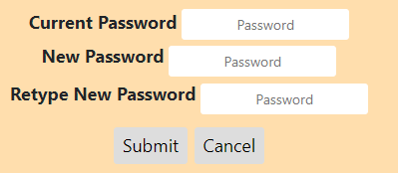

* 1. Adding a description modifies the bio of the user Image result for check

